CMPT306N-111 – Data Communications and Networks
Andrew Tokash
Hancock 1021 – Tuesdays & Fridays 9:30-10:45
Hancock 0006 – Fridays 11:00-12:15
Syllabus updated – January 3, 2022

“The Internet is just a world passing around notes in a classroom.”
– Jon Stewart
Catalog Course Description

This course examines the concepts and mechanisms of wired and wireless data-, audio-, and video-transport systems. Network architecture, terminology, control, standards (OSI and TCP/IP models), and general topologies will be discussed. Current equipment and physical interconnections will be explored for a range of network services to support activities such as application development, distributed processing, operating information centers, and providing distance learning. Topics covered include an analysis of the problems and limitations imposed by the physical channel, wireless networks, comparative switching techniques, routing, congestion control, and higher-level protocols needed to complete the end-user to end-user connection.

By the end of the course, students will be able to design computer networks, as well as demonstrate the fundamentals required for further CMPT courses like Internetworking and Cybersecurity. Students will also be fluent in binary and hexadecimal number systems.

Faculty Availability

Office Hours: Hancock 3002

“Going to office hours is one of the pieces of advice that is most often given, but rarely taken.” - Ellen Anderson

- I have office hours at least three days each week. Walk-ins welcome, but preference given to scheduled appointments. To see the current schedule: calendly.com/atokash
- I prefer ILearn messages (rather than email) for communications, as it keeps all of a course’s materials and communications in one place. If you do email me, please include the course and section number.
- Please use ILearn forum/discussion for general questions on material, expectations, etc. and for posting interesting topics for class discussion.

Required Text and Personal Laptop for Lab Exercises

- Business Data Communications & IT Infrastructures, 3rd Edition, Manish Agrawal and Clinton Daniel, Prospect Press
- The textbook’s supplementary chapters (15-17) are in iLearn resources
- We will be using WIRESHARK, NETSPO,T and other online tools
- Non-textbook material will also be presented on lecture slides.
- Please bring personal laptops for the hands-on portion of this class.
- Refer to my website for links to articles, videos, and other resources

Important Notes

In the event of a campus wide ‘pause’, we will be forced to hold classes remote. If that happens, students are expected to Zoom in and keep their video feeds live, and will be responsible for any class work covered during the normal class time. Also, in the event of inclement weather, we will hold classes remote!
I created a “Peer Lab Assistance” forum. If you have problems with a lab, you can post questions and/or lab files here to ask other students for assistance. Note: Peers should not FIX or modify your lab files; they should provide comments indicating what the problem may be.

Educational Approach / Activities / Philosophy of Education

“The value of a college education is not the learning of many facts but the training
of the mind to think." - Thomas Edison
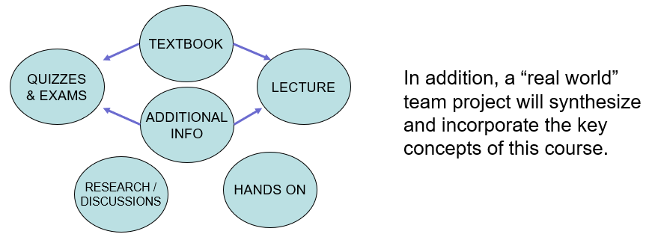

Computer Science Department Goals

“Today, companies expect not only technical hard skills, but also so-called professional skills [which] include communication, project management, conflict management, diversity management and teamwork.” – Marc-Oliver Pahl

- Prepare students for employment in a technology field or for graduate study in a technology field.
- Provide students with both theoretical knowledge and skills-based proficiencies in the five core technology competencies: programming, hardware, data communications, data management, and systems/software analysis and design.
- Provide students with fundamental knowledge of business administration and management so that graduates will be able to work effectively within businesses and other organizations.
- Develop interpersonal skills for working effectively on teams.
- Develop effective written and oral communication skills.

Course Objectives

- Understand standard networking protocols and the basics of data communications. [1,2]
- Understand the principles behind the design of data communications networks. [1,2,3]
- Understand hardware used to create local area networks, wide area networks, internets, and be able to design hardware/software infrastructure. [1,2,3]
- Understand software used to perform data communications exchanges. [1,2,3]
- Understand various communications technologies available to businesses, including telephony, leased lines, and cloud services. [1,3]
- Gain expertise in standard tools and applications used in networking. [1,2]
- Understand business requirements and security issues. [4]
- Understand the impact of the Internet on data communications and organizational processes. [1,2,3].
- Create and present a real-world (team) project applying fundamental concepts for a fictional business. [3,4,5]

Note: A detailed list of ‘core competencies’ is listed in the iLearn resources (file “Read Me First”). This list details, by weekly module, expected acquired knowledge topics and demonstratable skills.

Weekly Modules

Each week I will post in the ILearn resources the current module’s resources:
- A ReadMeFirst file with due dates, course progress, module contents, student requirements, and other information
- The PPT slides, which I am updating to include more information
- Videos posted in my shared Dropbox Library
- Modules may also include short videos with lectures and/or demonstrations
- Weekly quizzes, assignments and projects which will be due the following week

Coursework Submission Guidelines

Assignment, lab and project files must be submitted into ILearn. Documents must follow a standard naming convention and have proper page headers. Refer to the file “Submission Guidelines” in the Ilearn Resources section.

The guidelines file also lists information on using/citing references and the difference between a 90% A and a 100% A.

Students should spend at least two hours of outside time for each one hour of class time!

Diversity and Inclusion

The college's academic mission is immeasurably enriched by students with diverse experiences. Our finest efforts as intellectual beings heavily rely on the exchange of ideas. Interactions in our classrooms among persons and groups with diverse backgrounds, ideologies, and experiences facilitate these efforts by allowing us all to be more reflective about the varied historical and social contexts in which we work and learn.

In this course, we will challenge each other’s thinking while working collaboratively to ensure that the classroom is a space of safety and bravery. Our classroom offers an environment where individuals of varying opinions, experiences, and backgrounds can freely learn without fear of being silenced.
Aspects of diversity include, but are not limited to, race, ethnicity, color, nationality, sex, gender, gender identity, gender expression, class, sexual orientation, religion, age, ability, and veteran status. Students who would like to be identified in a manner other than what is indicated on the course roster can contact me privately to indicate name, pronoun and any other preferences they may have.

Learning Disabilities

Students have all types of learning disabilities. It is your responsibility to notify the professor in the beginning of the semester in order to make sure you are successful within this course! If you’re unsure whether you have a learning disability, make sure you see Special Services within Donnelly as soon as you suspect your disability!

Course Evaluation

Students are assessed via exams, self-assessment quizzes, assignments, and projects. Written projects and presentations will be used to assess their interpersonal, written and oral skills.

25% Assignments
10% Weekly Self Assessment Quizzes
30% Three Exams
15% Labs
15% Team Project and Presentations
5% Class Attendance/Participation

The aggregate grading policy for grading is a modified version of Marist’s grading schema, and will be displayed in the iLearn gradebook. Please continuously monitor your iLearn grade and contact me for any questions. Do not wait until final weeks to bring up any issues.

 | 94 A | 90 A-
87 B+ | 83 B | 80 B-
77 C+ | 73 C | 70 C-
65 D+ | 60 D

The weekly quizzes will be based primarily on the textbook, which I expect students to read.

All assignments, labs and quizzes are to be submitted by the due date specified. Late submissions may NOT be accepted! Also, I generally do not provide extra-credit or make-up assignments. These policies are in place to prepare you for the expectations of future employment.
Make-up opportunities for assignments, assessments, and exams are provided only for verifiable extenuating circumstances cleared through CAAS. Acceptable excuses for late submission of assignments include situations covered in the Student-Athlete Handbook, illness, and serious extenuating circumstances (e.g., death in the family, serious illness).

Semester schedule

Below is the tentative rough semester schedule. It is a work in progress and will change through the semester. The updated and “current” schedule will be maintained in the READ ME FIRST file in iLearn resources.
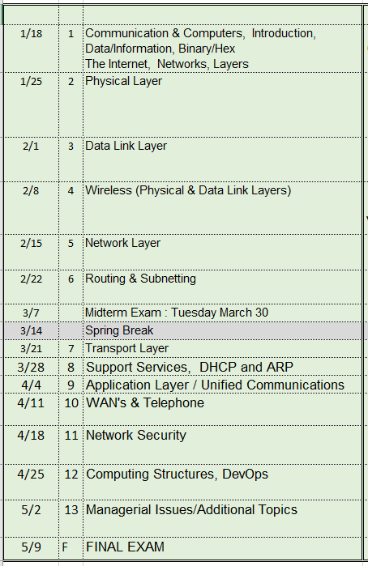

Academic Honesty

Faculty will uphold and enforce the general policies of this institution on academic honesty and plagiarism. All examinations, assignments, and projects are subject to the standards of academic honesty as described in the Student Handbook and/or other related publications.

Neither plagiarism not cheating will be tolerated. If you are suspected of cheating, you will be asked to explain the work. If you cannot you will be ejected from the course with a failing grade, in addition to any other forms of recourse available to the instructor as specified by the Student Handbook.

You are encouraged to discuss the course material, concepts, and lessons with other students in the class. However, your labs, exams and discussions must be your own work. If you are caught copying or otherwise submitting material that is not solely your work, you will fail the course and a letter will be sent to the department chair.

Please consult the ACM code of ethics. See www.acm.org/constitution/code.html.

Textbooks and PowerPoint Slides

Good note taking is a key skill for active learning, and reading the textbook is a requirement for the course. For these reasons I will release in Ilearn only the Power Point slides of material that is not from our textbook. (There are copyright restrictions, as well).

Steps to Getting an “A”

- Attend classes. If something is unclear ASK for a better/different explanation.
- Be an active student. Take notes, listen, speak, ask questions.
Refer to: http://www.dartmouth.edu/~acskills/success/notes.html
- Do a quick review of chapters BEFORE the class to identify confusing sections.
- Read the chapter and review each section’s TEST YOUR UNDERSTANDING questions.
- Do all assignments and submit them on time with proper formatting and citations. Begin assignments early in case you have questions.
- Do not copy assignments from other students, the Internet or any other source.
- Take your time with SELF ASSESSMENTS. Review material BEFORE taking the quiz.
- Study for the exams. Use the Core Competencies as a study guide.
- Work with other students and take advantage of office hours.
- Monitor your grades weekly.
- Use a flashcard application (ex: Quizlet) to help you study. Use the publisher’s flashcards if available.
- Participate fully in team projects!
- Use the Marist Writing Center and the other resources.
- If you have any questions, confusion or issue, address them immediately. Do not wait until the end of the semester to do so.

Changes to This Syllabus

01/03/2022 Preliminary syllabus

End of Document

The reference number in brackets [ ] indicates the department goal that is being met with the fulfillment of the objective.

